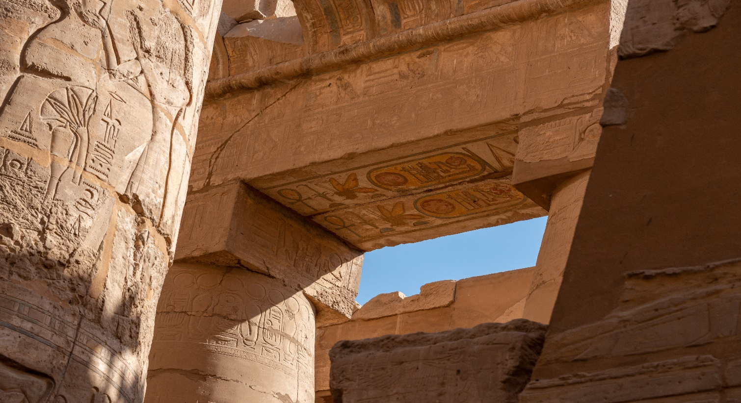

**Karnak Temple**

Karnak Temple, located in Luxor, Egypt, is a vast ancient complex dedicated to various deities and renowned for its impressive Hypostyle Hall with towering columns.

**History**

The Karnak Temple Complex in Luxor, Egypt, is a vast ancient religious site that evolved over 2,000 years, dedicated to various deities, with construction initiated in the Middle Kingdom around 2000 BCE.